
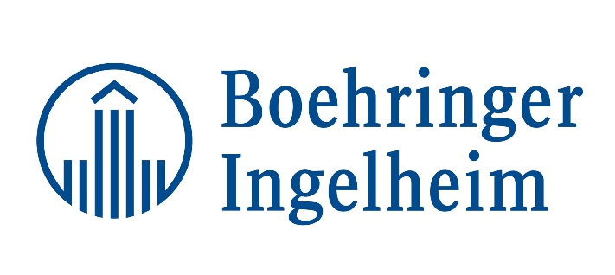
Join us for a Tour of Boehringer Ingelheim

Presentation will include an overview of the R & D Ames Site, process of getting a product from research to production and market, etc.

When: Wednesday, May 10, 2017
5:30-6:00 p.m. Registration/Networking
6:00-7:00 p.m. Dinner, Chapter Business & Door Prize
7:00-8:00 p.m. Presentation
Where: 2412 South Loop Dr, Ames, IA 50010
Cost: Free to CI-APICS and APICS Student Members,
$30 CI-APICS Non-Members
Please Note: No Pictures.
A Visitor Agreement will need to be signed at Registration Table.

If after registering, you find you can’t attend, please contact the Director of Finance at randy@rustersports.com (515) 707-7514

